**Name:** Affan Khan

**Roll No:** 19P-0045

**Section:** BCS 5-A

# Computer Networks Lab 10 – Homework

**Implementation:**

## Topology:

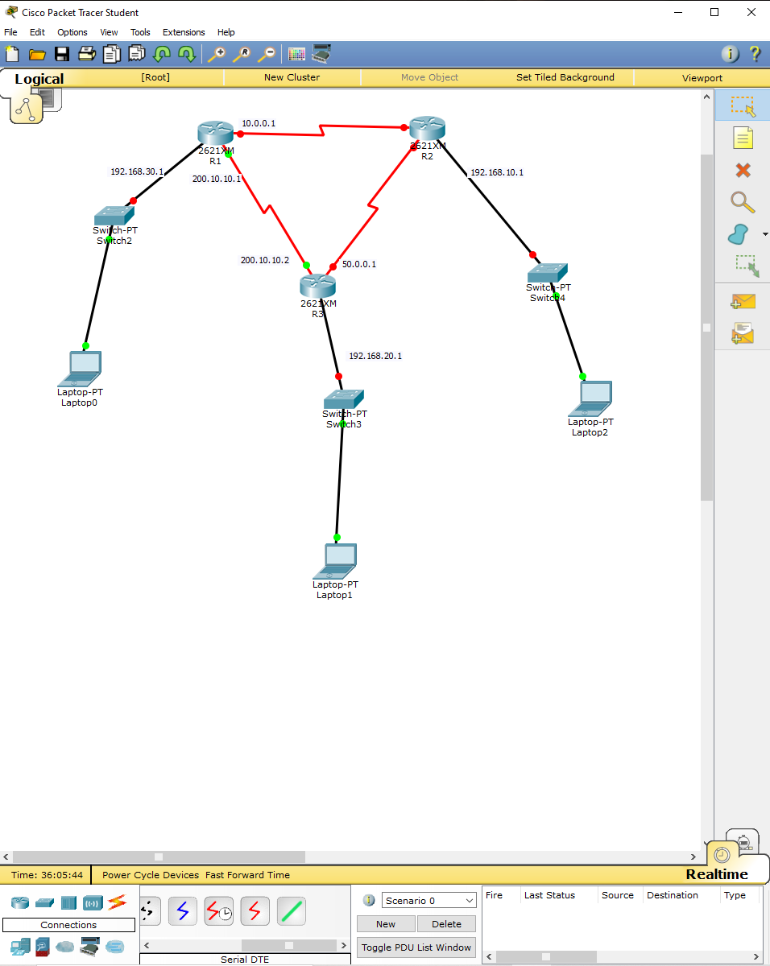

## 1. Setting Router Hostnames:

**a. Router 1:**

Renaming router 1’s hostname to ‘R1’.

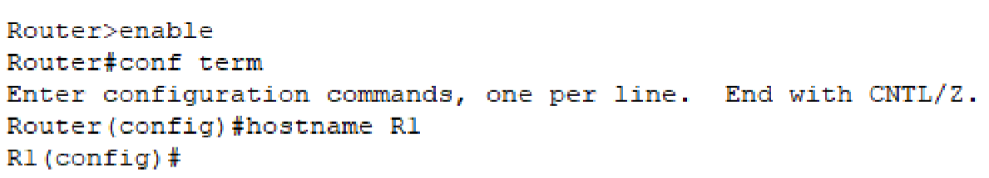

**Router 2:**

Renaming router 2’s hostname to ‘R2’.

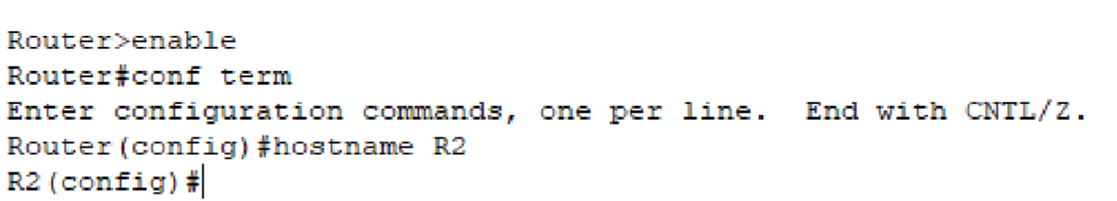

**c. Router 3:**

Renaming router 3’s hostname to ‘R3’.

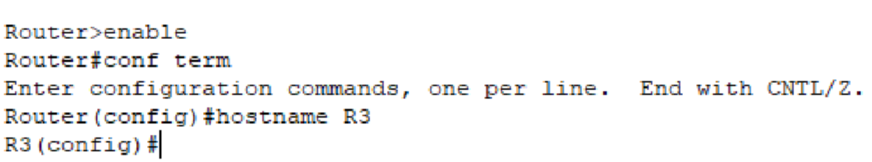

## 2. Adding IPs to Router Interfaces:

**a. R1:**

R1 has three interfaces connected to it. Hence, a different IP will be assigned to each interface.

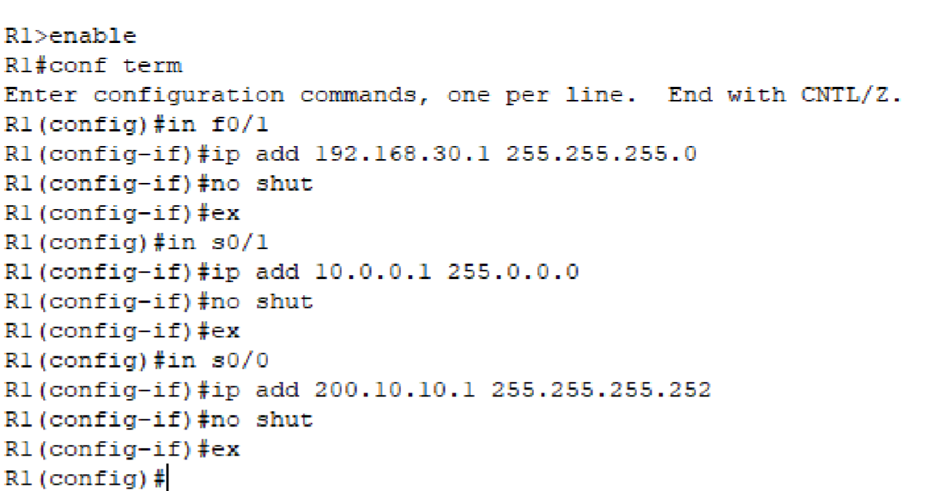

### fig 1.4

**R2:**

R2 also has three interfaces. A different IP will be assigned to each interface.

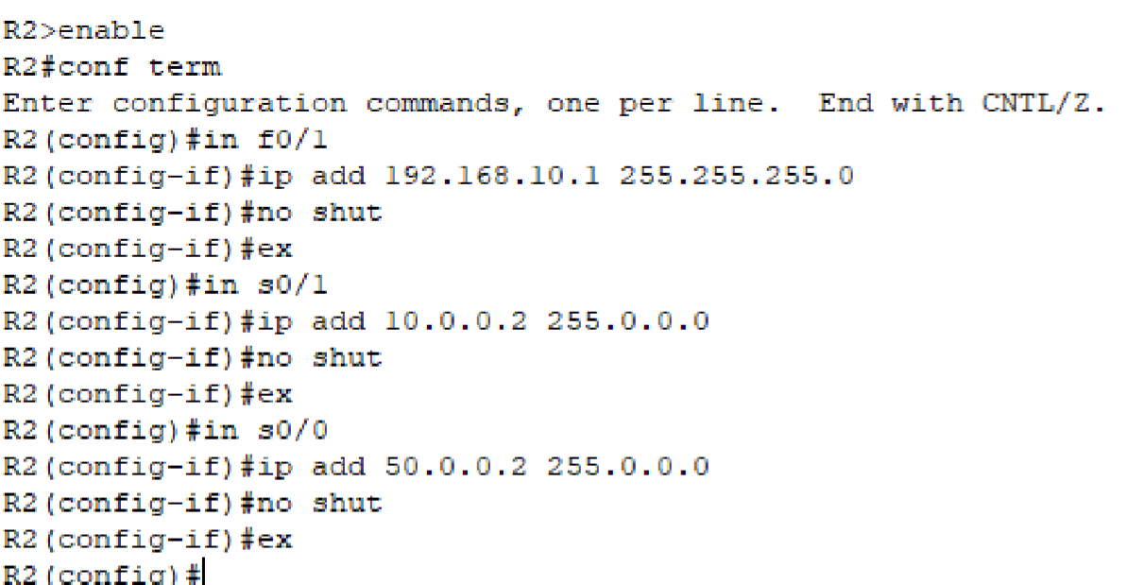 **fig 1.5**

**c. R3:**

Same with R3 having three interfaces. A different IP will be assigned to each interface.

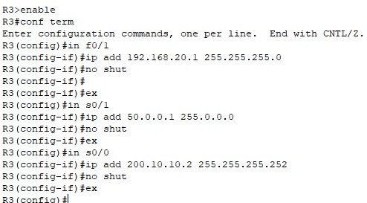

## 3. Creating DHCP Pools:

The first pool will be created from R1, given the name ‘p1’. Also, the default-route address will be removed from the DHCP IP pool.

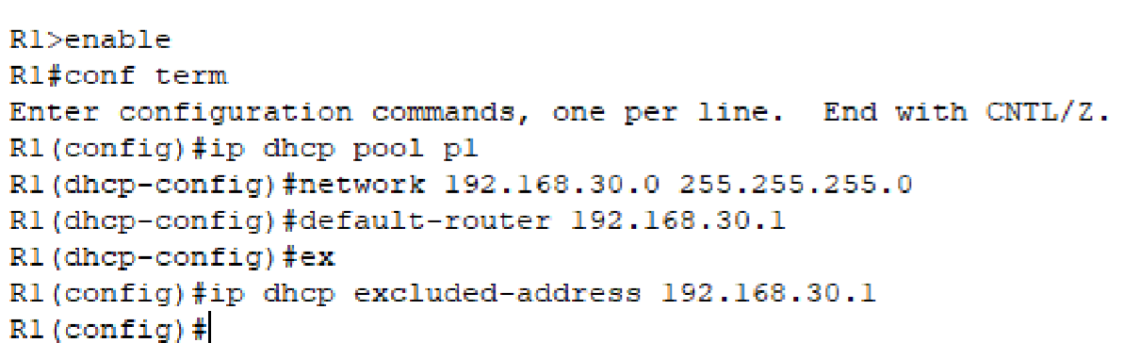

The second pool will be created using R2, given the name ‘p2’. Also, the default-route address will be removed from the DHCP IP pool.

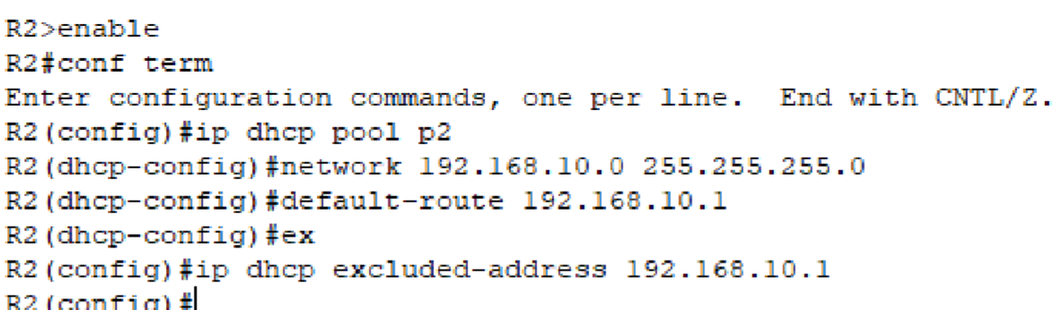

The third and the final pool will be created using R3, given the name ‘p3’ and the default-route address will be excluded from the DHCP IP pool.

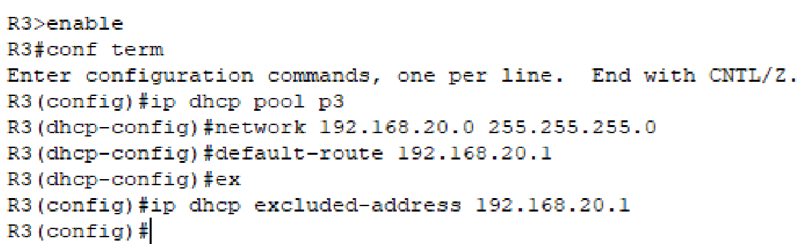

## 4. Setting up Router Routes:

1. **R1:**

Since R1 is connected to two end networks (one from each router). It is going to need two routing commands.

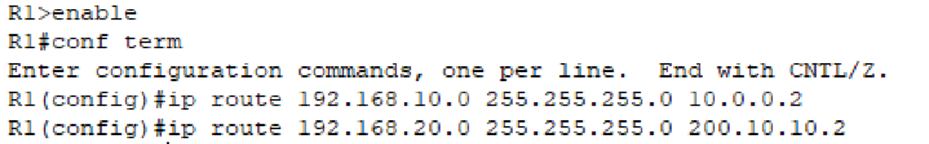

1. **R2:**

Similar to R1, R2 is connected to two end networks via R1 and R3 respectively. It is going to need two routing commands.

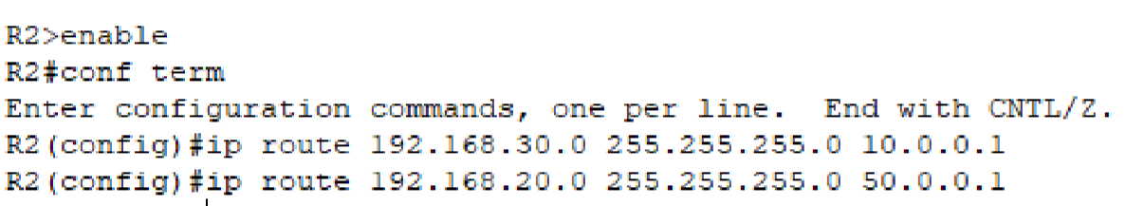

**c. R3:**

Similar to the other two routers, R3 is connected to two end networks via R1 and R2 respectively. It is going to need two routing commands.

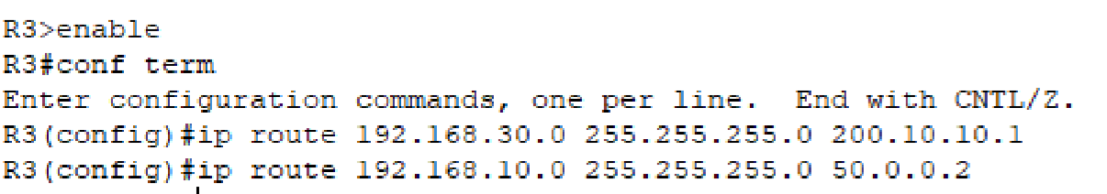

### fig 2.4

**How many networks are there?**

There are a total of **6 (six) networks**.



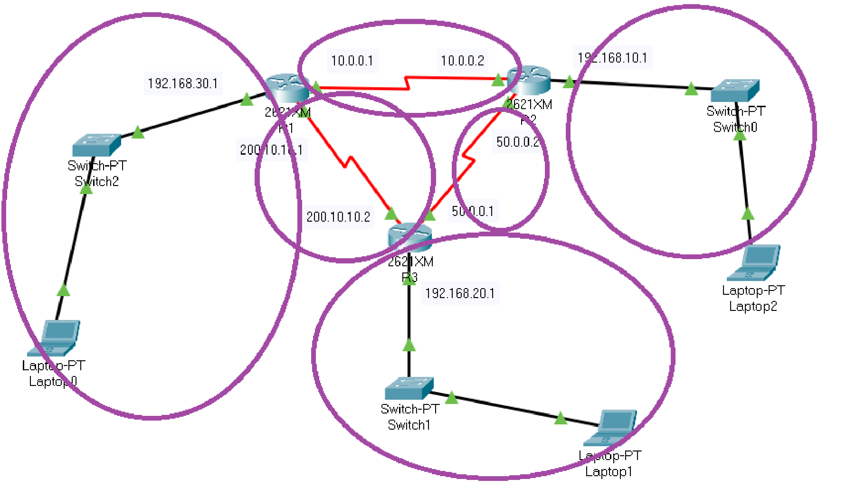

### fig 2.5